

Project Initialization and Planning Phase

Date | 18-feb- 2026
Team ID | LTVIP2026TMIDS25024
Project Name | Visualizing Housing Market Trends: An  Analysis of Sale Prices and Features using Tableau
Maximum Marks | 3 Marks

Visualizing Housing Market Trends: An Analysis of Sale Prices and Features using Tableau

The housing market is influenced by several factors, including location, property size, amenities, and economic conditions. Understanding these factors is crucial for homebuyers, investors, and real estate professionals to make informed decisions. However, traditional real estate reports and raw
datasets are often complex and difficult to interpret.

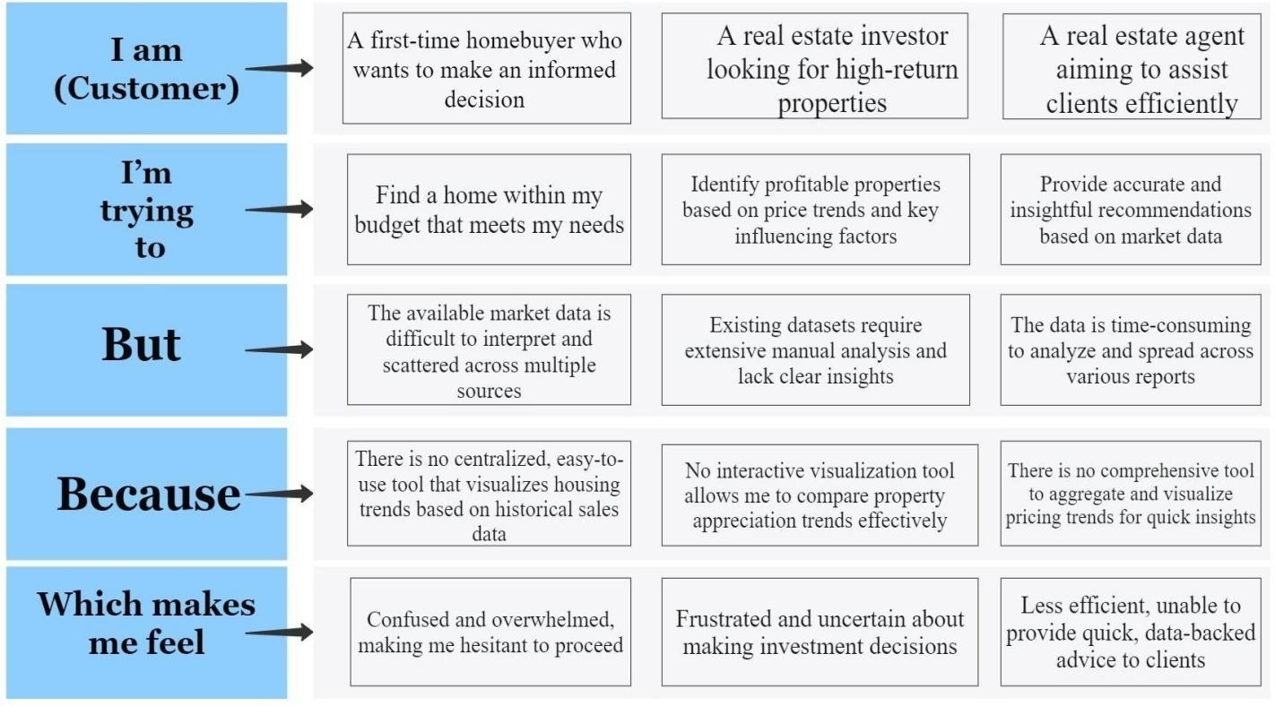



Problem Statement (PS) | I am (Customer) | I’m trying to | But | Because | Which makes me feel
PS-1 | A first-time  homebuyer who wants to make an informed  decision | Find a home within my  budget that meets my needs | The available market data is difficult to  interpret and  scattered across multiple sources | There is no centralized, easyto-use tool that visualizes housing trends  based on historical sales data | Confused and  overwhelmed, making me hesitant to proceed
PS-2 | A real estate investor  looking for high-return properties | Identify profitable properties based on  price trends and key  influencing factors | Existing datasets require  extensive  manual analysis and lack clear  insights | No interactive  visualization tool allows me to compare property appreciation  trends effectively | Frustrated and uncertain about  making investment decisions

PS-3 | A real estate  agent aiming to assist clients efficiently | Provide accurate and insightful  recommend ations based on market  data | The data is  timeconsuming to analyze and spread across  various reports | There is no  comprehensive  tool to aggregate and visualize  pricing trends for quick insights | Less efficient, unable to provide quick,  databacked advice to clients

